
Adding Student Accounts
* You will use this to add students to your account.
Step 1: Go to Accounts Tab and under “Your Student Accounts” you will click on “Manage all Accounts”
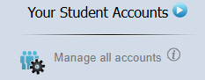
Step 2: Once you click on “Manage all Accounts” you will see a bright green box. Next to Add Accounts you can enter one or multiple students at a time.
Click this for a short how-to video!

Step 3: Adding “Multiple” option (spreadsheet option)
- You can add in each student’s information
- You can copy and paste from your class
mgmt. system (LMS) (to PASTE click Ctrl + V) 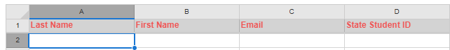

Step 4: After all student information is entered correctly click “Save & Continue”.


Step 5: Once you hit “Save & Continue” you will review and edit if needed. Then you must hit “Add Accounts” for your students to be added to your account.

